

National Relay Service

Quarterly Performance Report
Quarter 2, 2016–2017

Contents
Background 2
Cost of delivering the NRS 2
Service level performance: relay service provider 2
Service level performance: outreach service provider 3
Outreach service provider performance against Key Performance Indicators (KPIs) 4
Successful inbound connections (by inbound service access type) 5
Outbound call minutes relayed (by inbound connection type) 7
Calls to emergency services relayed through the NRS 7
Helpdesk enquiries 8

Background
The National Relay Service (NRS) providers are required to submit activity and performance data to the Department of Communications and the Arts (DoCA) each quarter. We use these reports to review the performance of the NRS providers against agreed service levels and key performance indicators, along with information provided in the data about how the NRS has been used in the quarter.
DoCA reports on:
- the cost of delivering the NRS on a quarterly basis
- the performance of the NRS providers against agreed service levels and key performance indicators for the relevant financial year, and
- information on how the NRS is used, including the number of successful inbound connections, the volume of outbound call minutes generated by each service access option, the number of calls to emergency services and the volume of different types of contact with the NRS helpdesk.
This quarterly report provides regular transparency of ongoing costs and the NRS providers' performance in delivering the NRS.

Cost of delivering the NRS
The annual cost of delivering the NRS varies, as the relay service component is affected by the number of call minutes relayed during the financial year. The cost of providing the NRS is funded from the telecommunications industry levy paid by eligible telecommunications carriers.
The cost (GST-inclusive) of providing the NRS in Quarters 1–4, 2016–17 is outlined in the table below:
Table 1. Cost of delivering the NRS
 | Quarter 1 | Quarter 2 | Quarter 3 | Quarter 4 | Total YTD
Relay service | $6,716,170 | $6,866,655 |  |  | $13,582,825
Outreach service | $1,067,452 | $1,067,452 |  |  | $2,134,904
Total | $7,783,622 | $7,934,107 |  |  | $15,717,729

Service level performance: relay service provider
The relay service provider’s performance in 2016–17 is measured monthly against the following service levels:
- Service level 1 (a): at least 85 per cent of calls are answered by a call taker within five seconds of reaching the relevant answering point for the call.
- Service level 1 (b): at least 95 per cent of calls are answered by a call taker within 10 seconds of reaching the relevant answering point for the call.
- Service level 2: no more than two per cent of calls abandoned after leaving the Interactive Voice Response (IVR) or being presented to the call routing queue (monthly average).
- Service level 3: no less than 95 per cent raw accuracy of words (excluding video relay). Raw accuracy is measured through monthly staff assessments of relay officers.
The relay service provider’s reported performance against these service levels is outlined in the table below:
Table 2. Service level performance: relay service provider
 | Jul-16 | Aug-16 | Sep-16 | Oct-16 | Nov-16 | Dec-16 | Jan-17 | Feb-17 | Mar-17 | Apr-17 | May-17 | Jun-17
Service level 1(a) | 94.95% | 96.21% | 97.40% | 98.10% | 96.40% | 96.63%
Service level 1(b) | 95.49% | 96.69% | 97.78% | 98.60% | 96.95% | 97.19%
Service level 2 | 0.56% | 0.44% | 0.38% | 0.31% | 0.44% | 0.31%
Service level 3 | 97.62% | 97.45% | 97.28% | 97.41% | 97.21% | 97.27%

The relay service provider has reported fully meeting all service levels in quarter 2 in 2016–17. The Department considers the performance of the relay service provider to be consistent with its obligations in the Relay Services Agreement.

Service level performance: outreach service provider
The outreach service provider’s performance in 2016–17 is measured monthly against the following service levels:
- Service level 1: the service contractor personnel must answer greater than 85 per cent of all telephone calls from Help Desk Users during the hours of operation of the Help Desk within 90 seconds. Any call other than a call that is ended by the user hanging up within 5 seconds from the first ring tone of the call is included in measurement of compliance with this Service Level.
- Service level 2: the service contractor personnel must acknowledge greater than 85 per cent of all enquiries received through public NRS email addresses or forms from the NRS website or from Help Desk Users within 4 hours where the enquiry is received before 2 pm (AEST) on a business day or otherwise by 12 noon (AEST) on the next business day.
- Service level 3: the service contractor personnel must resolve greater than 85 per cent of all enquiries received from Help Desk Users by telephone (that are not able to be resolved while on the call), website or email, that it is able to resolve without input from the Commonwealth or the relay service provider or a third party within 2 business days.
- Service level 4: the service contractor personnel must resolve greater than 85 per cent of all complaints received during the month within the timeframes required under the agreement (including the complaint handling policy) for the type of complaint.
The outreach service provider’s reported performance against these service levels is outlined in the table below:
Table 3. Service level performance: outreach service provider
 | Jul-16 | Aug-16 | Sep-16 | Oct-16 | Nov-16 | Dec-16 | Jan-17 | Feb-17 | Mar-17 | Apr-17 | May-17 | Jun-17
Service level 1 | 99.62% | 97.79% | 99.84% | 99.80% | 100% | 99.74%
Service level 2 | 100% | 99.76% | 100% | 100% | 100% | 99.14%
Service level 3 | 97.87% | 99.43% | 98.84% | 97.66% | 97.80% | 97.11%
Service level 4 | 86.77% | 100% | 100% | 100% | 100% | 100%

The outreach service provider has reported fully meeting all service levels in quarter 2, 2016–17. The Department considers the performance of the outreach service provider to be consistent with its obligations in the Outreach Services Agreement.

Outreach service provider performance against Key Performance Indicators (KPIs)
In addition to the service levels, the performance of the outreach service provider in 2016–17 is reported against a number of Key Performance Indicators (KPIs).
The outreach service provider’s reported performance against these measures, along with associated annual targets, are outlined in the table below:
Table 4. Outreach service provider: performance against Key Performance Indicators (KPIs)
 | Q1  2016–17 | Q2  2016–17 | Q3  2016–17 | Q4  2016–17 | Actual Activity YTD | KPI  Annual Target | % Actual Activity against Anticipated
KPI 1.1: Number of participants at Awareness Sessions | 394 | 363 |  |  | 757 | 1,600 | 47%
KPI 1.2: Number of promotion/conference events (National) | 4 | 5 |  |  | 9 | 7 | 129%
KPI 2.1: Number of training sessions x individual | 45 | 69 |  |  | 114
KPI 2.2: Number of training sessions x group demonstration | 48 | 41 |  |  | 89
KPI 2.3: Number of training sessions x group hands-on | 4 | 7 |  |  | 11
Total number of training sessions | 97 | 117 |  |  | 214 | 390 | 55%
KPI 2.4: Participants in training sessions x individual | 39 | 67 |  |  | 106 | 134 | 79%
KPI 3.1: Number of orgs commencing Relay Service Friendly Program (RSFP) | 14 | 13 |  |  | 27 | 40 | 68%
KPI 3.2: Number of orgs completing the training step within RSFP | 14 | 9 |  |  | 23 | 30 | 77%
KPI 3.3: Number of orgs completing the RSFP | 4 | 10 |  |  | 14 | 15 | 93%
KPI 3.4: Number of contact centres involved in Hearing Awareness Week (HAW) 2016 | 318 | N/A | N/A | N/A | 318 | 250 | 127%
KPI 3.5: Number of contact centre agents involved in HAW 2016 | 54,454 | N/A | N/A | N/A | 54,454 | 30,000 | 182%
The number of reported participants in individual training sessions represents current or potential users of the NRS. There may be some sessions with particular individuals with an outcome that they will not use the NRS because of personal circumstances or because they are a party who might support a NRS user.

Successful inbound connections (by inbound service access type)
Inbound connections are made by users of the relay service—either someone with a hearing and/or speech impairment or someone wishing to contact a person with such an impairment.
The graph below shows a month by month breakdown of the successful call connections for each NRS inbound service access type for the 2016–17 year to date:
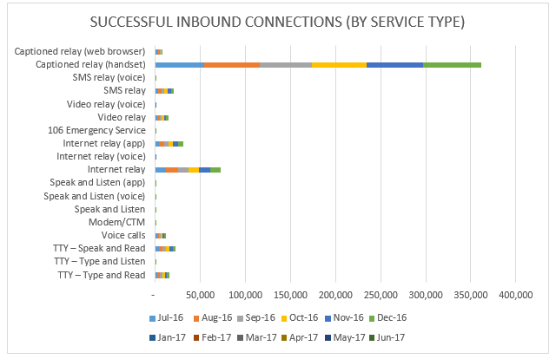
285,028 successful inbound connections were made to the NRS in quarter 2, 2016–17 representing a slight increase of just over 3% from the previous quarter.
Use of captioned relay and the NRS app by internet relay users continued to grow slightly in this quarter, with use of the TTY remaining in gradual decline. Similarly to the previous quarter, approximately two-thirds of all successful connections to the NRS in quarter 2, 2016–17 were made by captioned relay handset users.

Outbound call minutes relayed (by inbound connection type)
The following graph shows a breakdown of the outbound call minutes for each inbound connection type for the 2016–17 year to date:
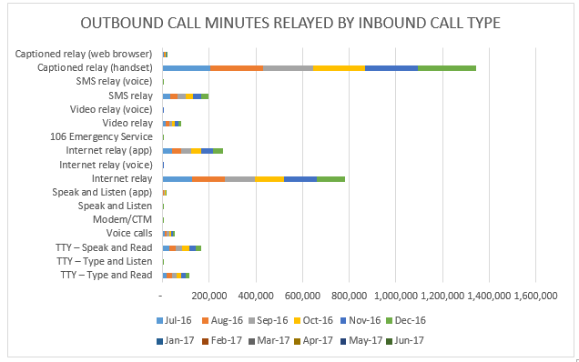
1,535,546 call minutes were relayed in quarter 2, 2016–17 which is a slight increase from the previous quarter (1,501,894 call minutes).

Calls to emergency services relayed through the NRS
All NRS calls (except for the video relay service, which has limited operating hours) requesting emergency services are given priority access to a relay officer within the relay service provider’s internal system, before being connected to either a Triple Zero operator or directly to the appropriate emergency service organisation for TTY 106 text emergency calls.
The chart below illustrates the ways in which NRS users accessed emergency services in the 2016–17 year to date:
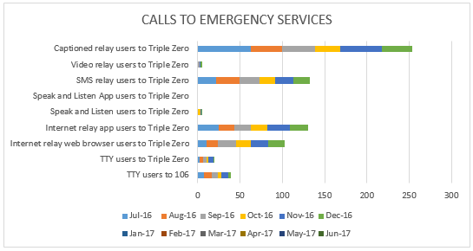
333 calls to emergency services were relayed in quarter 2, 2016-17, compared to 356 in the previous quarter.
Use of captioned relay, SMS relay, and internet relay again accounted for approximately 9 out of every 10 calls made to emergency services through the relay service in this quarter.

Helpdesk enquiries
The outreach service provider provides a Help Desk support function and handles complaints and feedback about the service.
The graph below illustrates a breakdown of the types of helpdesk enquiries received in the 2016–17 year to date:
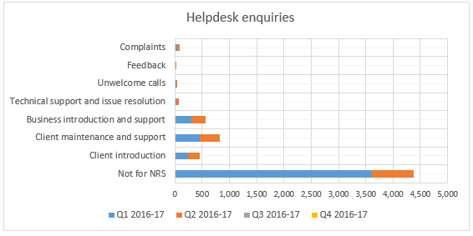
Help Desk activities for quarter 2, 2016-17 remained largely unchanged compared to usual activity. The Help Desk experienced an elevated volume of ‘not for us’ calls in the previous quarter, these levels returned to normal for this quarter. There were no other significant changes in the types of support enquiries received at the NRS Helpdesk.
‘Not for us’ calls (760), client maintenance and support (369), business introduction and support (264), and client introductions (202) remained the primary functions undertaken by the Help Desk this quarter.

