

National Relay Service

Quarterly Performance Report
Quarter 3, 2015–2016

Background
The NRS providers are required to submit activity and performance data to the Department of Communications and the Arts (DoCA) each quarter. We use these reports to review and manage the delivery of the NRS.
DoCA reports on:
- the cost of delivering the NRS on a quarterly basis;
- the performance of the NRS providers against the service levels, key activity measures and key performance indicators outlined in the NRS Plan; and
- information on how the NRS is used, including inbound and outbound call volumes and the service options that callers use to access the NRS.
This provides greater transparency of the NRS providers' performance and ongoing costs in delivering the NRS. Information provided in quarterly performance reporting will be consolidated into the annual reporting requirements that are due at the end of the financial year.

Cost of delivering the NRS
The annual cost of delivering the NRS varies, as the relay service component is based on the number of call minutes relayed during the financial year. The cost of providing the NRS is funded from the telecommunications industry levy paid by eligible telecommunications carriers. The annual funding allocation for the provision of the NRS is currently $22 million (including GST).
The cost (GST-inclusive) of providing the NRS in Quarters 1, 2 and 3, 2015–16 is outlined in Table 1 below:
Table 1. Cost of delivering the NRS
 | Quarter 1 | Quarter 2 | Quarter 3 | Quarter 4 | Total YTD
Relay service | $5,152,548 | $5,246,979 | $5,593,155 |  | $15,992,682
Outreach service | $1,047,549 | $1,047,549 | $1,047,549 |  | $3,142,647
Total | $6,200,097 | $6,294,528 | $6,640,704 |  | $19,135,329

Service level performance: relay service provider
The relay service provider’s performance in 2015–16 is measured monthly against the following service levels:
- Service level 1 (a): at least 85 per cent of calls are answered by a call taker within five seconds of reaching the relevant answering point for the call
- Service level 1 (b): at least 95 per cent of calls are answered by a call taker within 10 seconds of reaching the relevant answering point for the call
- Service level 2: no more than two per cent of calls abandoned after leaving the Interactive Voice Response (IVR) or being presented to the call routing queue (monthly average)
- Service level 3: no less than 95 per cent raw accuracy of words (excluding video relay). Raw accuracy is measured through monthly staff assessments of relay officers.
The relay service provider’s performance against these service levels is outlined in Table 2 below:
Table 2. Service level performance: relay service provider
 | Jul-15 | Aug-15 | Sep-15 | Oct-15 | Nov-15 | Dec-15 | Jan-16 | Feb-16 | Mar-16
Service level 1(a) | 95.46% | 95.45% | 95.27% | 94.60% | 94.39% | 94.62% | 95.11% | 94.36% | 95.16%
Service level 1(b) | 96.09% | 96.02% | 95.89% | 95.22% | 95.11% | 95.47% | 95.90% | 95.20% | 95.82%
Service level 2 | 0.78% | 0.75% | 0.69% | 0.88% | 0.98% | 0.79% | 0.54% | 0.37% | 0.64%
Service level 3 | 97.28% | 97.73% | 97.67% | 97.98% | 97.57% | 97.72% | 97.55% | 97.01% | 96.80%

The relay service provider fully met all service levels in Quarter 3, 2015–16. The Department considers the performance of the relay service provider to be consistent with its obligations in the Relay Services Agreement.

Service level performance: outreach service provider
The outreach service provider’s performance in 2015–16 is measured monthly against the following service levels:
- Service level 1: the service contractor personnel must answer greater than 85 per cent of all telephone calls from help desk users during the hours of operation of the Help Desk within 90 seconds. Any call other than a call that is ended by the user hanging up within 5 seconds from the first ring tone of the call is included in measurement of compliance with this Service Level;
- Service level 2: the service contractor personnel must acknowledge greater than 85 per cent of all enquiries received through public NRS email addresses or forms from the NRS website or from helpdesk users within 4 hours where the enquiry is received before 2 pm (AEST) on a business day or otherwise by 12 noon (AEST) on the next business day;
- Service level 3: the service contractor personnel must resolve greater than 85 per cent of all enquiries received from helpdesk users by telephone (that are not able to be resolved while on the call), website or email, that it is able to resolve without input from the Commonwealth or the relay service provider or a third party within 2 business days; and
- Service level 4: the service contractor personnel must resolve greater than 85 per cent of all complaints received during the month within the timeframes required under the agreement (including the complaint handling policy) for the type of complaint.
The outreach service provider’s performance against these service levels is outlined in Table 3 below:
Table 3. Service level performance: outreach service provider
 | Jul-15 | Aug-15 | Sep-15 | Oct-15 | Nov-15 | Dec-15 | Jan-16 | Feb-16 | Mar-16
Service level 1 | 99.96% | 99.46% | 99.56% | 99.99% | N/A | 99.99% | 98.10% | 99.19% | 99.41%
Service level 2 | 100% | 100% | 100% | 99.99% | 99.99% | 100% | 99.37% | 99.36% | 100%
Service level 3 | 99.55% | 99.55% | 98.46% | 99.99% | 99.99% | 99.99% | 98.99% | 99.42% | 97.53%
Service level 4 | 100% | 92.86% | 91.67% | 99.92% | 100% | 100% | 92.86% | 100% | 100%

The outreach service provider has fully met all service levels in Quarter 3, 2015–16. The Department considers the performance of the outreach service provider to be generally consistent with its obligations in the Outreach Services Agreement.

Outreach service provider performance against Key Activity Measures (KAMs)
In addition to the service levels, the performance of the outreach service provider in 2015–16 is measured against a number of Key Activity Measures (KAMs) and Key Performance Indicators (KPIs).
The outreach service provider’s performance against these measures, along with associated annual targets, are outlined in Table 4 below:
Table 4. Outreach service provider performance against Key Activity Measures (KAMs)
 | Q1  2015–16 | Q2  2015–16 | Q3  2015–16 | Q4  2015–16 | Actual Activity YTD | KPI  Annual Target
KAM 1.1: # organisations with contact centre operations for the eleven phone numbers most frequently called through the NRS that are engaged with the Relay Service Friendly Programme | 0 | 0 | 1 |  | 1 | 5
KAM 2.1: # simulated NRS call journeys completed between 1 January 2016 and 30 June 2016  (to commence in early 2016) | N/A | N/A | 0 |  |  | 250
KAM 2.2: New NRS branding and related guidelines completed by 28 February 2016 | N/A | N/A | Completed
KAM 2.3: Build of new NRS website is finalised by 30 June 2016 | N/A | N/A | N/A
KAM 2.4: # clickthroughs from Australia to simulated call portal  (to commence in early 2016) | N/A | N/A | N/A |  |  | 2,000
KAM 3.1: # participants in Training Sessions relevant to people with complex communication needs which cover mobile NRS calls including through the NRS app | 21 | 23 | 53 |  | 97 | 40
KAM 3.2: # participants in Awareness Sessions relevant to people with complex communication needs which cover mobile NRS calls including through the NRS app | 77 | 36 | 137 |  | 250 | 100
KAM 3.3: # TTY users introduced to mobile NRS calls including through the NRS app | 14 | 193 | 444 |  | 651 | 115

Optus formally engaged with the Relay Service Friendly Programme (RSF) in Quarter 3, 2015–16, completing Steps 1 & 2 of the Programme.
Outreach also engaged with several other major organisation regarding their participation in the RSF Programme—the Department of Human Services, Telstra, Suncorp (AAMI), the Commonwealth Bank of Australia and the Australian Taxation Office (KAM 1.1). However, as these are large organisations with complex structures, securing approval for RSF programme participation often involves various decision-makers across multiple departments and can be a lengthy process.
KAM 2.1 and 2.4 are reliant on the development of the NRS Call Tutorial which is due for deployment in Quarter 4.
KAM 2.3: is a project that is due for completion by 30 June 2016.
KAM 3.3 is a key priority for the Outreach service in 2015–16, involving activities which expose and encourage existing TTY users to mobile NRS call options, including the NRS app. This was provided to a total of 444 TTY users in Quarter 3 via targeted training and awareness sessions. This is a 130% increase from Quarter 2, primarily due to two large training sessions at TAFE NSW Tamworth and Men’s Shed group sessions which accounted for 30% of the participants.

Outreach service provider performance against Key Performance Indicators (KPIs)
 | Q1  2015–16 | Q2  2015–16 | Q3  2015–16 | Q4  2015–16 | Actual Activity YTD | KPI  Annual Target | % Actual Activity against Anticipated
KPI 1.1: Number of participants at Awareness Sessions | 860 | 807 | 637 |  | 2,304 | 1,500 | 154%
KPI 1.2: Number of promotion/conference events (National) | 2 | 6 | 0 |  | 8 | 8 | 100%
KPI 2.1: Number of training sessions | 106 | 134 | 125 |  | 365 | 380 | 96%
KPI 3.1: Number of orgs commencing Relay Service Friendly Program (RSFP) | 9 | 12 | 14 |  | 35 | 70 | 50%
KPI 3.2: Number of orgs completing the training step within RSFP | 8 | 10 | 6 |  | 24 | 23 | 104%
KPI 3.4: Number of contact centres involved in Hearing Awareness Week (HAW) 2015 | 295 | N/A | N/A | N/A | 295 | 250 | 118%
KPI 3.5: Number of contact centre agents involved in HAW 2015 | 50,198 | N/A | N/A | N/A | 50,198 | 30,000 | 167%

Outreach delivered a total of 65 Awareness Sessions in Quarter 3, 2015–16 involving a total of 637 participants. This exceeds the annual KPI 1.1 target by 54%.
In total, 125 Training Sessions were conducted in Quarter 3, 2015–16 reaching 96% of the annual KPI 2.1 target.
14 new organisations commenced the Relay Service Ready Program during the quarter, including Lendlease, WA Country Health Services, MetLife Insurance Limited, and the Department of Defence. (KPI 3.1).
Four organisations completed the RSF Programme in Quarter 3, 2015–16—Real Insurance, Electoral Commission of Queensland, State Library of Victoria and Cootharinga Society of North Queensland. An additional six organisations are nearing completion of the RSF Programme.
Staff training was also delivered to six organisations, including the Insurance Commission of Western Australia and Recoveries and Reconstructions Australia. The annual target for KPI 3.2 has now been met at the nine-month point.

Successful call connections (by inbound call service type)
Inbound connections are made by users of the relay service – either someone with a hearing and/or speech impairment or someone wishing to contact a person with such an impairment.
The graph below shows a breakdown of the successful call connections for each NRS inbound call service type in Quarters 1, 2 and 3, 2015–16:
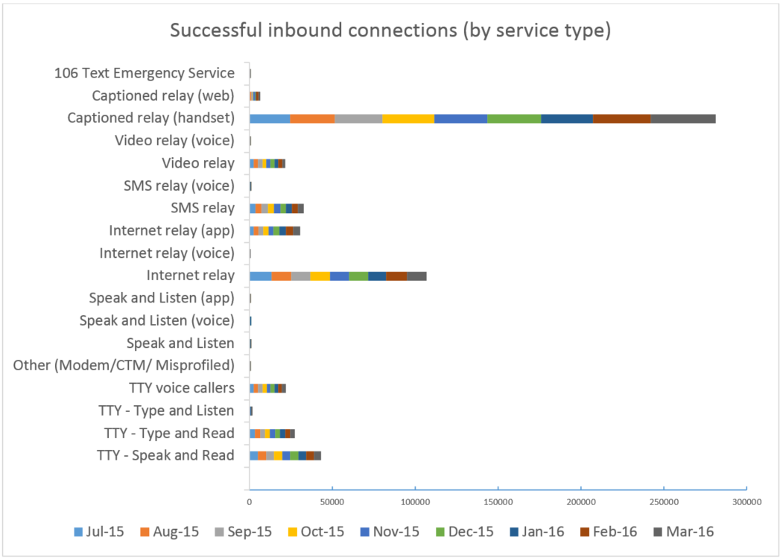
203,330 successful inbound connections were made to the NRS in Quarter 3, 2015–16 (up 5.07% from 193,518 in Quarter 2). Use of captioned relay and the NRS app by internet relay users continued to grow this quarter, with small reductions in the number of successful connections by most other call types in the same period. More than 50% of all successful connections to the NRS were made by captioned relay handset users in Quarter 3, 2015–16.

Outbound call minutes relayed (by inbound call type)
Outbound calls are placed by the relay service on behalf of users, primarily to businesses, government organisations, friends and family.
The following graph shows a breakdown of the outbound call minutes for each inbound call type in Quarters 1, 2 and 3, 2015–16:
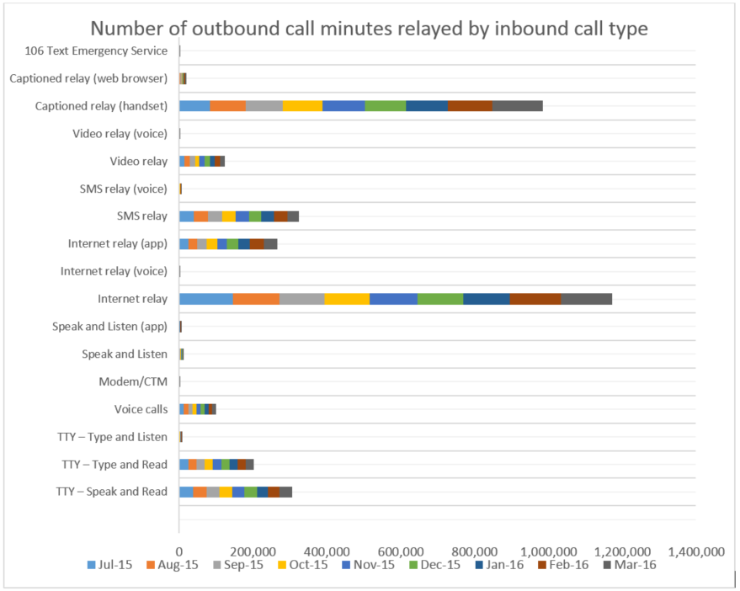
More than 1.23 million call minutes were relayed in Quarter 3, 2015–16, compared to around 1.15 million in the previous quarter. To date, more than 3.52 million calls minutes relayed since the start of FY 2015–16; an increase of 30% when compared to the first 9 months of the previous financial year (2.7 million in the first 9 months of 2014–15).

Calls to emergency services relayed by the NRS
All NRS calls (except for the video relay service, which has limited operating hours) requiring emergency services are given priority access to a relay officer, before being connected to either a Triple Zero operator or directly to the appropriate emergency service organisation.
The chart below illustrates a proportional breakdown of the ways NRS users accessed emergency services in the period between 1 July 2015 and 31 March 2016:
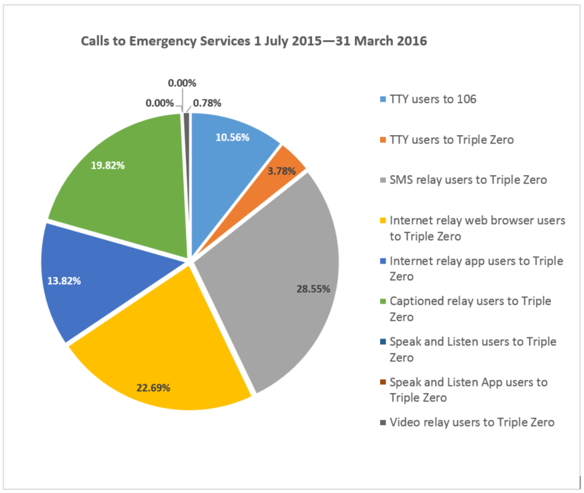
The number of calls to emergency services via the NRS decreased slightly in Quarter 3, 2015–16 with a total of 267 genuine calls, compared to 287 in Quarter 2. SMS relay was the most used option, with a total of 80 genuine calls made via this service access option. This represents 30% of all calls to emergency services during the quarter. More than 70% of all calls were made via internet relay, SMS relay and captioned relay, with calls by TTY users now less than 1 in 8.

Helpdesk enquiries
The outreach service provider provides a helpdesk support function and handles complaints and feedback about the service.
The graph below illustrates a breakdown of the types of helpdesk enquiries received during Quarters 1, 2 and 3, 2015–16:
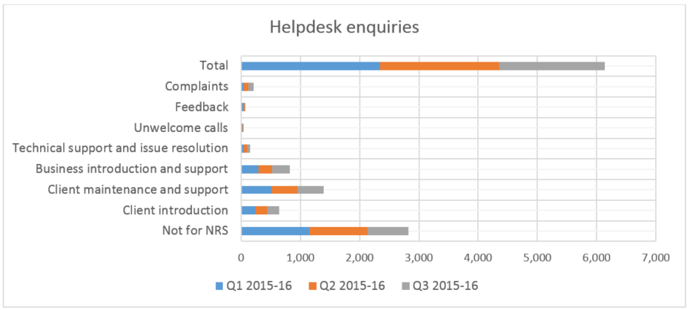

Compliance with the call answer time requirements of Service Level 1 could not be determined for the month of November 2015 as Helpdesk call answer time data was not recorded for the period 13-25 November 2015 (9 business days) due to an external system fault. The outreach provider has introduced more frequent monitoring of data collection related to Service Level 1 as a mitigation strategy, following the events in November 2015.
In the 12 months prior to the commencement of the relevant financial year

