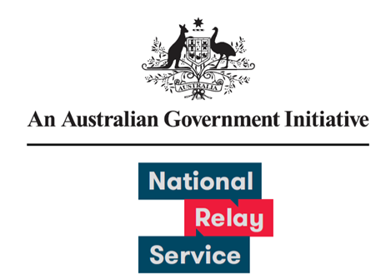

# User Experience Research Learnings

December 2022

Provided by Concentrix

Contents

Background & objective 3

Survey Approach Overview 3

Comparison between previous survey results 4

NRS User Survey Experience Ratings 5

Key Takeaways 6

## Background & objective

Users of the National Relay Service (NRS) have provided feedback on how the NRS can improve their experience and continues to meet the changing needs of the community. During this third survey, feedback was collected between 24 October – 20 November 2022.

## Survey Approach Overview

What we did differently

* Users were able to provide feedback via Auslan video
* Inclusion of specific questions about recent NRS Chat and Captions enhancements
* Reminders sent after 5 days

A total of 915 responses were received.

Survey responses by collection method

* There were 902 email responses. This is a 20% response rate.
* There were 13 post responses. This is a 33% response rate.

Survey responses were received from 7 States and Territories

* There were 297 responses from New South Wales and the Australian Capital Territory
* There were 243 responses from Victoria
* There were 230 responses from Queensland
* There were 58 responses from Western Australia
* There were 52 responses from South Australia
* There were 22 responses from Tasmania
* There was 1 response from the Northern Territory
* There were 13 responses where the user location was unknown. This includes responses from overseas and received via post.

## Comparison between previous survey results

82% - 86% of respondents had a positive experience with the relay service and gave an agree or strongly agree response. The round one User Survey was conducted in 2021 and received 133 responses. The round two User Survey was conducted in February 2022 and received 593 responses. The round three User Survey was conducted in November 2022 and received 893 responses.

**Please rate your experience across the following attributes:**

**I was satisfied with the service:**

* The survey results increased from 79% in round two to 82% in round three. This is a 3% change.

**The service met my need:**

* The survey results increased from 82% in round two to 85% in round three. This is a 3% change.

**I felt comfortable and confident using the service:**

* The survey results increased from 80% in round two to 85% in round three. This is a 5% change.

**The service was easy to use:**

* The survey results increased from 80% in round two to 86% in round three. This is a 6% change.

## NRS User Survey Experience Ratings

Conducted between 24 October 2022 and 20 November 2022, Sample size = 893

Please rate your most recent experience using the National Relay Service (scale from strongly disagree to strongly agree)

**I felt comfortable and confident using the National Relay Service**

* 3% chose Strongly Disagree
* 4% chose Disagree
* 7% chose Neither Agree Nor Disagree
* 40% chose Agree
* 45% chose Strongly Agree

**The service was easy to use**

* 3% chose Strongly Disagree
* 4% chose Disagree
* 7% chose Neither Agree Nor Disagree
* 41% chose Agree
* 45% chose Strongly Agree

**The service met my need**

* 4% chose Strongly Disagree
* 3% chose Disagree
* 7% chose Neither Agree Nor Disagree
* 39% chose Agree
* 47% chose Strongly Agree

**I was satisfied with the service today**

* 4% chose Strongly Disagree
* 5% chose Disagree
* 9% chose Neither Agree Nor Disagree
* 38% chose Agree
* 44% chose Strongly Agree

## Key Takeaways

1. The number of users providing feedback increased (54% increase in response volume, round two 593 / round three 915)
2. There has been an increase in engagement with the survey (37% of active users completed the survey)
3. NRS Users continue to have a positive experience with the service
4. User experience attribute results (satisfied, met need, confident & comfortable) have continued to improve
5. User registration data has improved, with valid email addresses held for 99% of respondents
6. We are confident the results and feedback are representative of the NRS userbase
7. The ‘Contact Helpdesk Feedback Form’ will provide ongoing feedback on satisfaction with the NRS Helpdesk