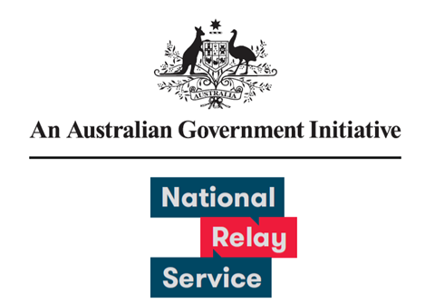

# User Experience Research Learnings

July 2022

Provided by Concentrix

Contents

Background & objective 3

Survey Approach Overview 3

What we did differently 3

Survey responses by collection method 3

Survey responses were received from 7 states and territories 3

Comparison between 2021 and 2022 survey results 3

NRS User Survey Experience Ratings 4

Conducted between 31st Jan’22 and 27th Feb’22, Sample size = 593 4

Key takeaways 4

## Background & objective

Listening to users and considering their feedback for continuous improvement is an important part of how the National Relay Service (NRS) ensures it meets evolving user and community needs. This survey is one of the ways the NRS collects data to measure progress of service enhancements and its impact to the NRS user experience against previous research conducted.

This report presents the survey results for the period 31st January to 27th February 2022 as well as a comparison of results from the NRS user survey conducted in February 2021.

## Survey Approach Overview

### What we did differently

* Survey questions were provided in AUSLAN and Text
* Increased collection period from 2 to 4 weeks
* Surveys sent via email the next business day following an interaction
* Surveys sent via sms and post to users who did not have an email address
* Reminders sent after 4 days

A total of 611 responses were received.

### Survey responses by collection method

* There were 588 email responses. This is a 13% response rate.
* There were 23 post responses. This is a 41% response rate.

### Survey responses were received from 7 states and territories

* There were 173 responses from New South Wales and the Australian Capital Territory
* There were 170 responses from Victoria
* There were 151 responses from Queensland
* There were 45 responses from Western Australia
* There were 35 responses from South Australia
* There were 10 responses from Tasmania
* There were 2 responses from the Northern Territory
* There were 25 responses where the user location was unknown. This includes responses from overseas and received via post.

## Comparison between 2021 and 2022 survey results

79% - 82% of respondents had a positive experience with the relay service and gave an agree or strongly agree response. The round one User survey was conducted in 2021 and received 133 responses. The round two User survey was conducted in 2022 and received 593 responses.

**Please rate your experience across the following attributes:**

**I was satisfied with the service:**

* The survey result increased from 71% in round one to 79% in round two. This is an 8% change.

**The service met my need:**

* The survey result increased from 76% in round one to 82% in round two. This is a 6% change.

**I felt comfortable and confident using the service:**

* The survey result increased from 75% in round one to 80% in round two. This is a 5% change.

**The service was easy to use:**

* This question wasn’t asked in round one, and received an 80% response in round two.

## NRS User Survey Experience Ratings

### Conducted between 31st Jan’22 and 27th Feb’22, Sample size = 593

Please rate your most recent experience using the National Relay Service (scale from strongly disagree to strongly agree)

**I felt comfortable and confident using the National Relay Service**

* 2% chose Strongly Disagree
* 6% chose Disagree
* 12% chose Neither Agree Nor Disagree
* 36% chose Agree
* 43% chose Strongly Agree

**The service was easy to use**

* 2% chose Strongly Disagree
* 4% chose Disagree
* 14% chose Neither Agree Nor Disagree
* 39% chose Agree
* 40% chose Strongly Agree

**The service met my need**

* 3% chose Strongly Disagree
* 4% chose Disagree
* 11% chose Neither Agree Nor Disagree
* 38% chose Agree
* 43% chose Strongly Agree

**I was satisfied with the service today**

* 3% chose Strongly Disagree
* 5% chose Disagree
* 13% chose Neither Agree Nor Disagree
* 38% chose Agree
* 41% chose Strongly Agree

## Key takeaways

1. NRS users continue to have a positive experience with the service
2. All user experience attribute results (satisfied, need met, confident & comfortable) have improved
3. User registration has facilitated more in-depth understanding of experience across demographics
4. We are confident the results and feedback is representative of the NRS user population