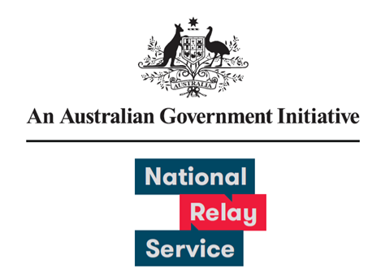

# User Experience Research Learnings

June 2023

Provided by Concentrix

Contents

Background & objective 3

Survey Approach Overview 3

Comparison between previous survey results 4

NRS User Survey Experience Ratings 5

Key Takeaways 6

## Background & objective

National Relay Service (NRS) users have provided feedback on how the NRS can improve the user experience and continue to meet the changing needs of the community. During this fourth survey, feedback was collected between 1 May and 31 May 2023.

## Survey Approach Overview

What we did differently

* Removed specific questions to gather feedback on recent NRS Chat and Captions enhancements from previous survey round.
* Reminders were sent after 4 days instead of 5.

A total of 728 responses were received.

Survey responses by collection method

* There were 712 email responses.
* There were 16 post responses.

Survey responses were received from 7 States and Territories

* There were 256 responses from New South Wales and the Australian Capital Territory
* There were 195 responses from Victoria
* There were 147 responses from Queensland
* There were 56 responses from Western Australia
* There were 41 responses from South Australia
* There were 14 responses from Tasmania
* There was 4 response from the Northern Territory
* There were 15 responses where the user location was unknown. This includes responses from overseas and received via post.

## Comparison between previous survey results

80% - 81% of respondents had a positive experience with the relay service and gave an agree or strongly agree response. The round one User Survey was conducted in 2021 and received 133 responses. The round two User Survey was conducted in February 2022 and received 593 responses. The round three User Survey was conducted in November 2022 and received 893 responses.

**Please rate your experience across the following attributes:**

**I was satisfied with the service:**

* The survey results were 77% in round four and 82% in round three. This is a 5% change.

**The service met my need:**

* The survey results were 81% in round four and 85% in round three. This is a 4% change.

**I felt comfortable and confident using the service:**

* The survey results were 80% in round four and 85% in round three. This is a 5% change.

**The service was easy to use:**

* The survey results were 81% in round four and 86% in round three. This is a 5% change.

## NRS User Survey Experience Ratings

Conducted between 1 May 2023 and 31 May 2023, Sample size = 728

Please rate your most recent experience using the National Relay Service (scale from strongly disagree to strongly agree)

**I felt comfortable and confident using the National Relay Service**

* 3% chose Strongly Disagree
* 5% chose Disagree
* 11% chose Neither Agree Nor Disagree
* 35% chose Agree
* 46% chose Strongly Agree

**The service was easy to use**

* 3% chose Strongly Disagree
* 5% chose Disagree
* 11% chose Neither Agree Nor Disagree
* 35% chose Agree
* 45% chose Strongly Agree

**The service met my need**

* 4% chose Strongly Disagree
* 4% chose Disagree
* 11% chose Neither Agree Nor Disagree
* 35% chose Agree
* 46% chose Strongly Agree

**I was satisfied with the service today**

* 5% chose Strongly Disagree
* 7% chose Disagree
* 11% chose Neither Agree Nor Disagree
* 33% chose Agree
* 45% chose Strongly Agree

## Key Takeaways

1. NRS users continue have a positive experience with the service on par with second round of surveys
2. Opportunities exist to engage with larger organisations regularly contacted by NRS users to improve call taking process
3. Options for improvements to user features
4. Considerations for further improvements to Relay Officer processes and training