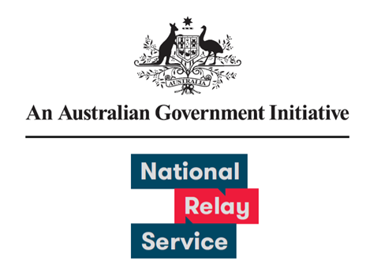

# User Experience Research Learnings

May 2024

Provided by Concentrix

Contents

Background and Objective 3

Survey Approach Overview 3

Comparison between previous survey results 4

NRS User Survey Experience Ratings 5

Key Takeaways 6

## Background and Objective

National Relay Service (NRS) users have provided feedback on how the NRS can improve the user experience and continue to meet the changing needs of the community. During this sixth survey, feedback was collected between 1 May and 31 May 2024.

## Survey Approach Overview

### What we did differently

* Questions were added to gather feedback on recent NRS User Portal, Chat and Captions enhancements released in February 2024

A total of 576 responses were received.

Survey responses by collection method

* There were 568 email responses.
* There were 8 post responses.

Survey responses were received from 7 States and Territories

* There were 185 responses from New South Wales and the Australian Capital Territory
* There were 139 responses from Victoria
* There were 135 responses from Queensland
* There were 51 responses from Western Australia
* There were 36 responses from South Australia
* There were 8 responses from Tasmania
* There was 4 response from the Northern Territory
* There were 18 responses where the user location was unknown. This includes responses from overseas and received via post.

## Comparison between previous survey results

84% - 87% of respondents had a positive experience with the relay service and gave an agree or strongly agree response. The round one User Survey was conducted in 2021 and received 133 responses. The round two User Survey was conducted in February 2022 and received 593 responses. The round three User Survey was conducted in November 2022 and received 893 responses. The round four User Survey was conducted in May 2023 and received 716 responses. The round five User Survey was conducted in November 2023 and received 730 responses.

**Please rate your experience across the following attributes:**

**I was satisfied with the service:**

* The survey results were 84% in round six and 79% in round five. This is a 5% change.

**The service met my need:**

* The survey results were 87% in round six and 83% in round five. This is a 4% change.

**I felt comfortable and confident using the service:**

* The survey results were 86% in round six and 83% in round five. This is a 3% change.

**The service was easy to use:**

* The survey results were 86% in round six and 83% in round five. This is a 3% change.

## NRS User Survey Experience Ratings

### Conducted between 1 May 2024 and 31 May 2024, Sample size = 576

Please rate your most recent experience using the National Relay Service (scale from strongly disagree to strongly agree)

**I felt comfortable and confident using the National Relay Service**

* 2% chose Strongly Disagree
* 4% chose Disagree
* 8% chose Neither Agree Nor Disagree
* 36% chose Agree
* 50% chose Strongly Agree

**The service was easy to use**

* 2% chose Strongly Disagree
* 2% chose Disagree
* 10% chose Neither Agree Nor Disagree
* 38% chose Agree
* 48% chose Strongly Agree

**The service met my need**

* 2% chose Strongly Disagree
* 2% chose Disagree
* 8% chose Neither Agree Nor Disagree
* 38% chose Agree
* 50% chose Strongly Agree

**I was satisfied with the service today**

* 2% chose Strongly Disagree
* 3% chose Disagree
* 10% chose Neither Agree Nor Disagree
* 37% chose Agree
* 47% chose Strongly Agree

## Key Takeaways

1. NRS users continue to have a positive experience with the service on par with fifth round of surveys
2. Opportunities exist to engage with organisations and businesses regularly contacted by NRS users to improve call taking process
3. Options for improvements to user features
4. Considerations for further improvements to user processes protocols Relay Officer training